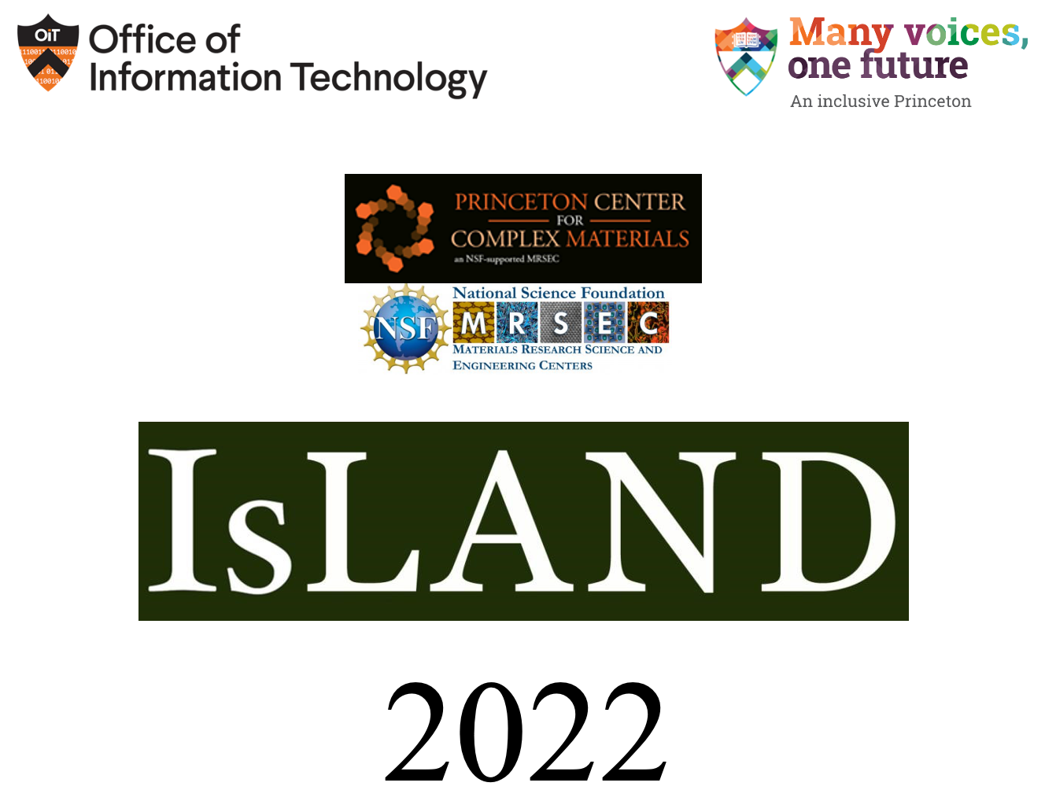

Inclusion in Science Learning: A New Direction

Conference on Disability and STEM

13th Annual ISLAND Conference
Bowen Hall, 70 Prospect Ave
Princeton University, New Jersey 08540
Friday, September 16th and Saturday, September 17th 2022

Sponsored by:
Princeton Center for Complex Materials (PCCM) NSF DMR # 2011750
Office of Information Technology, Princeton University
Campus Conversations on Identity, Princeton University
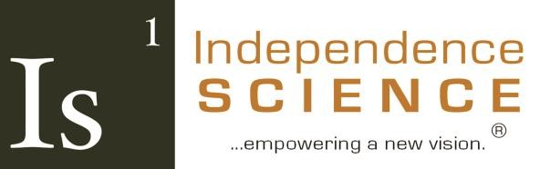
Independence Science

ISLAND Conference Mission
The Inclusion in Science: Learning A New Direction, Conference on Disability, (ISLAND) seeks to shift the societal paradigm and raise expectations as to what is possible in Science, Technology, Engineering, and Mathematics (STEM) education for persons with disabilities. Symposium topics encompass factors that contribute to the under-representation of persons with disabilities in the STEM pipeline and strategies for their retention in this critical area of the 21st century economies and societies of the Fourth Industrial Revolution.
At ISLAND, we believe it is through education that we will reach the hearts and minds of the public about what is possible for persons with disabilities and remove barriers to access. ISLAND presentations intend to drive innovation in pedagogy and methodology, while informing and connecting a community of teachers and future educators to the latest technological interventions and exploring methodological innovations ranging from simple access solutions for learning in a more inclusive way to global alternative praxis. Multisensory and hands-on approaches are emphasized during this conference, to stimulate and promote more equitable and inclusive student learning experiences.
The ISLAND conference, since its founding in 2010, continues to serve as a forum for conference attendees to meet, network, and collaborate to reshape the future of science access for students with disabilities. Originally organized and operated by scientists with disabilities who had a common mission to make the subjects they love more accessible and inclusive, ISLAND has grown to embrace a tapestry of non-disabled partners who have expressed a strong commitment to the full inclusion of persons with disabilities into the STEM professions. All individuals and organizations are welcome to participate at ISLAND.
The conference organizers hope that your participation is equally rewarding and fulfilling as it is for us. To us, the inclusion of persons with disabilities into the STEM professions is beyond commitment and passion – it is a calling. We are active in promoting the full and authentic inclusion of persons with disabilities within the scientific community through other professional societies and organizations of scientists. Come join our community of research and practice as we continue to further shift the societal paradigm to where a STEM professional with a disability becomes the norm rather than the exception.

Conference Schedule – Friday September 16, 2022

6:00 PM – 7:00 PM
Hors d’oeuvres and in-person networking

6:30 PM– 7:00 PM Eastern Daylight Time (GMT/UTC minus 4 hours)
Zoom open for registrant login and networking
Please call Carla Vallejo at 346-477-5064 for login support

7:00 PM – 7:05 PM
Welcome and Introductions
Dr. Cary Supalo

7:05 PM
Changing the Landscape of STEM Education for B/VI Students
Dave Schleppenbach
Tactile Engineering, Lafayette, Indiana

7:35 PM
High-Power, Low-Cost, Tactile Actuation Arrays Enabled by Soft Microcumbustion
Ronald Heisser
Cornell University, Ithaca, New York

8:05 PM
An Autobiography on Changes of Blindness
Charis Glatthar
Metro State Denver, Denver, Colorado

Conference Schedule – Saturday September 17, 2022

8:30 AM - 9:00 AM Eastern Daylight Time (UTC/GMT minus 4 hours)
Zoom open for registrant login and networking
Please call Carla Vallejo at 346-477-5064 for login support

9:05 AM
B/VI Accessibility Technology Adapted for Chemistry Students with Language-Based Disabilities
Christin Monroe
Landmark College, Putney, Vermont

9:35 AM
Synergizing Braille and Science: Real-Time Tactile Graphics Access in Science Laboratory Settings for Students Who are Blind
Ashley Nashleanas
Independence Science, Hinton, Iowa

10:05 AM
APH Presents the Submersible Audio Light Sensor (SALS):
A Device That Fosters Inclusion in Science
Rosanne Hoffman
American Printing House for the Blind, Louisville, Kentucky

10:35 AM
Morning Break

10:50 AM
Including BVI Students in NSF Funded Research Experience Programs
Daniel Steinberg
Princeton University, Princeton, New Jersey

11:20 AM
Deaf and Hard of Hearing Individuals Diversifying the STEM Workforce
through Increased Access to STEM Education
Jason Nordhaus and Jessica Williams
Rochester Institute of Technology, Rochester, New York

11:50 AM
An Introductory Course in Electrical Circuits and Coding for Deaf and Deaf Blind Middle School Students
Christina Yang
Saint Paul, Minnesota

12:00 PM

Lunch Break

1:00 PM- 1:55 PM

Keynote Speaker Bryan Shaw

2:00 PM
Using AI to Instantly Make STEM Images and Documents Accessible
Vijayshree Vethantham
Continual Engine, Dallas, Texas

2:30 PM
Mission Inspire: Having a BLAST with Students with Visual Impairments Learning STEM
Tiffany Wild
The Ohio State University, Columbus, Ohio
Tina Herzberg
University of South Carolina Upstate, Valley Falls, South Carolina

3:00 PM
TVIs Mathematical Pedagogical Content Knowledge
Tasnim Al Shuli
University of Arizona, Tucson, Arizona

3:15 PM– 3:30 PM

Afternoon Break

3:45 PM
Information on Wolfram Syndrome
Ellie White
Ellie White Foundation, Aurora, Colorado

4:15 PM
Development, Implementation, and Preliminary Outcomes from the Connecting Students with Autism to Geographic Information Science & Technology (CSA-GIST) Program
Jamie Pearson
North Carolina State University, Raleigh, North Carolina

4:45 PM
Project ATOM
Martin Goldberg, Ph.D.
Tinski Tech Inc. New York, New York

5:15 PM
Evaluation in a Science Assessment Context
Eric G. Hansen
Educational Testing Service, Princeton, New Jersey

5:45 PM
Concluding Remarks

6:00 PM
Zoom closes

Conference Abstracts

Friday 7:05 PM

Changing the Landscape of STEM Education for B/VI Students
Dave Schleppenbach
Tactile Engineering
Lafayette, IN
Modern education’s heightened emphasis on STEM subjects better prepares students for high-demand careers, but these graphics-intensive subjects are often very difficult for blind and low-vision individuals.
Tactile Engineering has begun production of Cadence, a graphical tactile display intended to dramatically improve access to animated, interactive diagrams, images, and charts. The realization of such a device has been a dream goal for the accessibility industry for decades, and there have been countless attempts over the years. Cadence is designed from the ground up to be affordable, mass-producible, and durable, in order to be available to as many B/VI individuals as possible.
Tactile Engineering has partnered with Independence Science to develop and test accessible laboratory tools, using the Cadence along with custom software and probes to collect and display data in real time. TE and IS recently tested several of these systems at the National Federation of the Blind conference, allowing attendees to learn, use, and evaluate the Cadence’s capabilities. We will discuss the unique aspects of the Cadence device and use cases for its software and features. Audience members will be invited to work with the devices and offer feedback.

Friday 7:35 PM

High-Power, Low-Cost, Tactile Actuation Arrays Enabled by Soft Microcumbustion
Ronald Heisser
Cornell University, Ithaca, New York
Organic Robotics Laboratory (PI: Robert Shepherd)
In our lab, we are conducting soft robotics research to develop a new high-density array mechanical actuation system. We have produced an initial proof-of-concept whereby fuel/oxygen mixtures are spark-ignited inside microliter-volume, silicone rubber combustion chambers, producing rapid actuation pulses int rubber membranes. The high energy and power density of the fuel produces a pulse powerful enough to lift small pins or bistable elements. The array is a thin, tough, conformable silicone sheet. The exceedingly simple manufacturing method allows for an arbitrarily large number of dots to be made at diminishing cell cost. Though our concept is unconventional, we believe that it deserves serious consideration for future multi-line braille and graphical displays.

Friday 8:05 PM: An Autobiography on Changes of Blindness
Charis Glatthar
Metro State Denver
Denver, Colorado
Blind accessibility in STEM fields is a growing process, but lack of tools with the high levels of precision and accuracy needed for upper level science classes, reluctance on the part of many instructors to teach students on level with their classmates due to the sheer amount of time it takes to make their PowerPoints and other materials accessible, and frustration from students due to lack of those same materials, are just a few of the barriers that turn many blind students away from STEM fields.
I became blind 3 years ago. I have experienced the contrast in post-secondary science classes pre-blindness and post blindness, in the interactions with professors and students, tools needed to succeed, the importance of advocacy at individual and university levels, the issues caused when there is a lack of hands-on approach, and the need for more blind accessibility materials in STEM.

Saturday 9:05 AM

B/VI Accessibility Technology Adapted for Chemistry Students with Language-Based Disabilities
Christin Monroe
Landmark College, Putney, Vermont
Text-to-speech technology incorporated into laboratory data collection devices has allowed B/VI students and professionals to perform hands-on experiments with real time data collection. Individuals with language-based learning differences (dyslexia, dyscalculia, etc.) commonly use text-to-speech accommodations for their coursework. To date, the text-to-speech technology adapted for B/VI individuals has not been tested with individuals with language-based learning differences. This presentation will showcase several examples of chemical experiments where the text-to-speech data collection has been utilized for students with language-based learning differences. The presentation will also include a summary of feedback collected from students.

Saturday 9:35 AM

Synergizing Braille and Science: Real-Time Tactile Graphics Access in Science Laboratory Settings for Students Who are Blind
Ashley Nashleanas
Independence Science
Hinton, Iowa
To date, there has never been a tool that provides opportunities for students with blindness and low vision (BLV) to perform data collection and analysis in the form of multi-line, real-time, and refreshable tactile graphics when in a laboratory setting. This form of data access is necessary for students with BLV to receive an equitable experience when working in a laboratory setting with their nondisabled peers. Building on the concept of the Sci-Voice Talking LabQuest, which allows students with BLV to perform data collection activities in an auditory way, the Sci-Dot is a multiline, refreshable braille and tactile graphics display. This technological advancement is a game-changer in the STEM access world, providing students with BLV the opportunity to engage with their nondisabled peers more timely and directly than ever before. I will present results on the usability of the current prototype as experienced by individuals with BLV who attended this year's National Federation of the Blind (NFB) convention, along with developments in progress based on participant feedback.

Saturday 10:05 AM

APH Presents the Submersible Audio Light Sensor (SALS); A Device That Fosters Inclusion in Science
Rosanne Hoffman
American Printing House for the Blind
Louisville, Kentucky
APH presents the Submersible Audio Light Sensor (SALS); A device that fosters inclusion in science.
The American Printing House for the Blind released the Submersible Audio Light Sensor (SALS) for sale in the summer of 2022. SALS comprises a 25-cm long light-detecting probe connected to an iOS or Android app via BluetoothÂ®. Detected levels of light are converted to a tone produced by mobile devices and tablets via the SALS app. SALS is unique because it detects light in liquids as well as in air. As light levels decrease, the tone pitch becomes lower; and if light levels increase, the pitch becomes higher. SALS is useful for students with visual impairment, as it provides audible notification of a visual change in an experimental parameter. For example, when a precipitate is formed in a test tube, or when a pH indicator changes from a light to a darker color, a decrease in tone would be discerned. Sound is heard as a tone or stated in Hertz, and students can save and compare tones with the app. The presentation will include a demonstration of the SALS probe and app.

Saturday 10:50 AM

Including BVI Students in NSF Funded Research Experience Programs
Daniel Steinberg
Princeton, New Jersey
We explore the needs and requirements to provide successful, independent research experience for Blind and Visually Impaired (BVI) students in cutting edge research labs. We wish to provide meaningful, independent, research opportunities for BVI students. We will discuss the Research Experience for Undergraduates (REU) and other education and outreach programs run by National Science Foundation (NSF) funded centers.
Most research labs are currently not prepared to provide the support and we contend that ongoing discussions and work groups dedicated to providing guidance for these BVI research experience would extremely helpful in attaining our goal. Our goal for this presentation is to reach out to the community to create successful BVI student research projects in the very near future and share the results with the community.

Saturday 11:20 AM

Deaf and Hard of Hearing Individuals Diversifying the STEM Workforce through Increased Access to STEM Education
Jason Nordhaus and Jessica Williams
Rochester Institute of Technology, Rochester, New York
A robust national STEM (Science, Technology, Engineering and Mathematics) workforce benefits significantly from participation from diverse groups (e.g. minorities, people with disabilities, people who learn English as a second language). One way to diversify the STEM workforce is to empower those who have historically been marginalized, such as deaf and hard-of-hearing (DHH) people, to gain the skills to pursue STEM degrees. DHH people earn STEM bachelor’s degrees at a lower rate when compared to hearing people (15.5% DHH vs. 24.9% hearing; Walter & Dirmyer, 2013). DHH individuals may not have the same access to STEM education due to language barriers. Many STEM concepts do not have well-developed or well-known American Sign Language (ASL) signs to describe the concept accurately. Further, many DHH individuals do not have access to ASL interpreters who are also experts in STEM disciplines. Using an interdisciplinary model, we created physics educational videos using conceptually accurate ASL. The videos were shared with DHH students, professors, and interpreters to use in the university physics classroom. Preliminary data demonstrates that DHH college students can learn physics concepts from the educational videos. We will discuss what we have learned so far as well as next steps.

11:50 AM

An introductory Course in Electrical Circuits and Coding for Deaf and Deaf Blind Middle School Students
Christina Yang
Saint Paul, Minnesota
The Playful Learning Lab collaborated with Metro Deaf School (MDS) to design and deliver an Intro to Electronics and Computer Programming course to Deaf and DeafBlind middle school students. Four sets of 6-8 students went through an approximately 20-day course that met four days a week for 40 minutes per day. The content of the class focused on electrical circuits and computer programming. Lessons covered topics such as conductivity, closed/open circuits, series/parallel circuits, and coding. Students were introduced to the Scratch computer programming language and Makey Makey kits.
The development and delivery of the course was a collaborative effort between Metro Deaf School staff and the undergraduate student researchers in the Playful Learning Lab. The class was a project-based mix of lectures, projects, and hands-on assignments. In this presentation we will share the lessons learned by designing, and delivering, this course.

Saturday 2:00 PM

Using AI to Instantly Make STEM Images and Documents Accessible
Vijayshree Vethantham
Continual Engine, Dallas, Texas
Continual Engine’s products PREP and Invicta are innovations in accessible technology that enable equitable access. By harnessing the power of artificial intelligence (AI), machine learning, automation, and other technologies in an unprecedented manner, our products make content accessible for all individuals. The ultimate goal of Continual Engine’s accessibility products is to handle all types of complex STEM images at every education level.
PREP PDF and Document Remediation Platform is a document accessibility platform that accelerates and automates the process of making PDFs and other documents accessible for individuals with visual or cognitive disabilities who use screen readers. PREP minimizes the need for manual intervention as it automates tagging for even complex structures like tables and lists.
PREP offers a lot of advantageous solutions that defies the challenges for accessibility in education.
- Accelerates the time involved in making complex STEM documents accessible
- Develops a cost-effective solution that easily fit into institutional budgets
- Shortens the learning curve when using PREP to easily integrate new users or part-time users
- Easily understandable and accessible for faculty or non-expert users
- Also offers video resources to enable on-demand learning
- Supports multiple document formats, structures, complexities, and large volumes
Our AI-powered solution Invicta serves as a one-stop solution to generate high quality and compliant accessible alt text. Invicta disrupts the tedious and expensive approach to content accessibility, allowing the publishing houses to cater to a larger audience and create a level playing field for everyone to access the content. Invicta automates the task of generating high-quality, accurate alt-text for images of varying complexities within a significantly shorter turnaround time and at a reduced cost.

Saturday 2:30 PM

Mission Inspire: Having a BLAST with Students with Visual Impairments Learning STEM
Tiffany Wild
The Ohio State University, Columbus Ohio
Tina Herzberg
University of South Carolina Upstate, Valley Falls, South Carolina
We had a BLAST working with our students with visual impairments to collect data, work in the scientific method and practice presentation skills all while setting off rockets. Blast off with us on Mission Inspire to learn how you too can create your own mission for your students. Our mission goal is to inspire teachers to advocate for the inclusion of students with visual impairment into academic and science fair competitions in their home districts or states. As part of our mission, we work to serve as a model and reference for any future competitions that can be planned because of this initial launch. Join is in 3, 2, 1!

Saturday 3:00 PM

TVIs Mathematical Pedagogical Content Knowledge
Tasnim Al Shuli
University of Arizona, Tucson, Arizona
This paper will investigate teachers of students with Visual Impairments (TVIs) perspective regarding students with Visual Impairments (SVIs) learning and experiences in mathematics education while exploring mathematics Teaching practices of TVIs, TSVIs role in SVIs mathematical education, SVI mathematical learning, accessibility of mathematical content materials, and equity in mathematics education for SVIs. Additionally, this paper will also include a study discussing findings and implications from an interview targeted to TSVIs.

3:45 PM

Information on Wolfram Syndrome
Ellie White
Ellie White Foundation, Aurora, Colorado
Wolfram Syndrome is an extremely rare genetic disorder. It can also be referred to as DIDMOAD (diabetes insipidus diabetes mellitus optic atrophy deafness). There is little known about this disorder, but with the research being done, new things are discovered.
The Ellie White Foundation is a foundation I started to raise awareness for families, research facilities, and medical centers. Fundraising is an additional goal, I do fundraising around the country to donate 100% of the earnings to the research facility that is doing the most successful research. I was diagnosed with Type One Diabetes when I was three years old, and I have no family history. When I was seven years old, I was diagnosed with Wolfram Syndrome, after finding out that I had significant vision loss. I was slowly losing my vision until I was about 15 years old, then it decreased rapidly. I am now using a cane, reading braille, and utilizing technology to get through school. The largest goal for me in life is to live life to the fullest, and help other people understand their meaning in life.

Saturday 4:15 PM

Development, Implementation, and Preliminary Outcomes from the Connecting Students with Autism to Geographic Information Science & Technology (CSA-GIST) Program
Jamie Pearson
North Carolina State University, Raleigh, North Carolina
In 2015, the United Nations created a new disability initiative, recognizing that more than 15% of the global population are people with disabilities who face unique challenges in accessing opportunities for safety, security, and economic empowerment (2019). Autism is the fastest growing developmental disability in the nation (CDC, 2020a), and autistic adults find it more challenging to find meaningful work than other individuals with disabilities (Roux et al, 2015). The number of autistic children served in North Carolina public schools drives the need for better strategies to support the development and future employment of autistic youth (CDC, 2020b; 2015). We know that many students with autism thrive in stimulating STEM careers when given proper support. As such, the Connecting Students with Autism to Geographic Information Science & Technology (CSA-GIST) study established a research-based workforce development model that: (1) increases student self-regulation, interest, and motivation in Geographic Information Science & Technology (GIST) and (2) expands students understanding of GIST/STEM concepts and skill sets in an effort to better prepare autistic high school students for post-secondary STEM education and careers. In this presentation, we will discuss the development and implementation of GIST, and highlight preliminary findings following year one of the project.

Saturday 4:45 PM

Project ATOM
Martin Goldberg, Ph.D.
Tinski Tech Inc, New York, New York
Project ATOM is Tinski Tech Inc.’s flagship project. It addresses the Orientation and Mobility problem of handling the Frustrating Final Fifty Feet. Current solutions such as Aira, BeMyEyes, and BlindSquare are helpful but fall short of the promise. Project ATOM proposes a chaperone solution that provides a virtual companion to each person who needs it. Using an interactive system first described in Martin Goldberg’s Doctoral Thesis, Tinski Tech intends to build a system that should help the BVI community deal with unfamiliar and constantly changing environments.

Saturday 5:15 PM

Evaluation in a Science Assessment Context
Eric G. Hansen, Mark T. Hakkinen, Jason J. White, Carlos Cavalie, Hui Jin, & Jason Bonthron
Educational Testing Service
Princeton, New Jersey
Individuals who are blind and use screen readers face challenges in obtaining a quick overview of numerical data in tables because they must navigate cell by cell, listening to the individual values. The demands on working memory can quickly exceed available capacity, slowing the user’s speed in solving problems involving patterns or trends in the data. We developed a web standards-based, cross-browser sonification tool that allows users to hear entire columns (or rows) of numbers as a quick succession of tones. After thus obtaining an overview of the data, the user can then zoom in to examine specific values, using a screen reader. Such a capability was expected to be valuable to users of screen readers who are blind. We also report on a small-scale evaluation of the user interface of the tool by adult screen reader users (N = 7) in the context of realistic science assessment tasks involving time series data. The majority of the participants in this evaluation expressed agreement with statements asserting that the sonification capability was easy to use, easy to learn to use, and useful. Areas for future development include enhancements to the keyboard interface and to the user instructions.

ISLAND 2022 Acknowledgements
ISLAND’s conference organizers thank you for participating. We hope you found the presentations and informal discussions informative, interesting, insightful, and useful for your teaching and research.
We feel the ISLAND conference serves as an active forum to improve science education. We grow our community so that more people encounter, become interested in, and are informed about how to effectively promote inclusion and equity in STEM. We believe that as STEM education and related industries and professions become aware of the talents and challenges of people with disabilities and learn how to provide accommodations in an effective and inclusive way, they will embrace, not fear, the participation of persons with disabilities in STEM.
We look forward to your continued interest and participation in the ISLAND community and activities in the months and years to come. We invite all attendees to join our online community. We also invite all interested presenters to submit a peer reviewed paper for the ISLAND proceedings issue of the Journal of Science Education for Students with Disabilities (JSESD). This open access free journal has is a valuable resource for science educators and researchers alike. Details about deadline submissions and publication guidelines, as well as previous ISLAND conference proceedings are available on the JSESD website.
The ISLAND conference organizers thank our sponsors for helping to make this year’s conference a huge success: Princeton University’s Office of Information Technology, Princeton University’s Campus Conversation on Identities, the Princeton Center for Complex Materials (PCCM), an NSF-funded MRSEC DMR # 2011750, and Independence Science. It is their support that made an inclusive ISLAND 2022 possible.
We look forward to welcoming you to the 14th annual ISLAND conference. Please check back on the ISLAND conference website for dates and details.

Cary Supalo
Jasodhara Bhattacharya
Daniel Steinberg
Mary Albert

